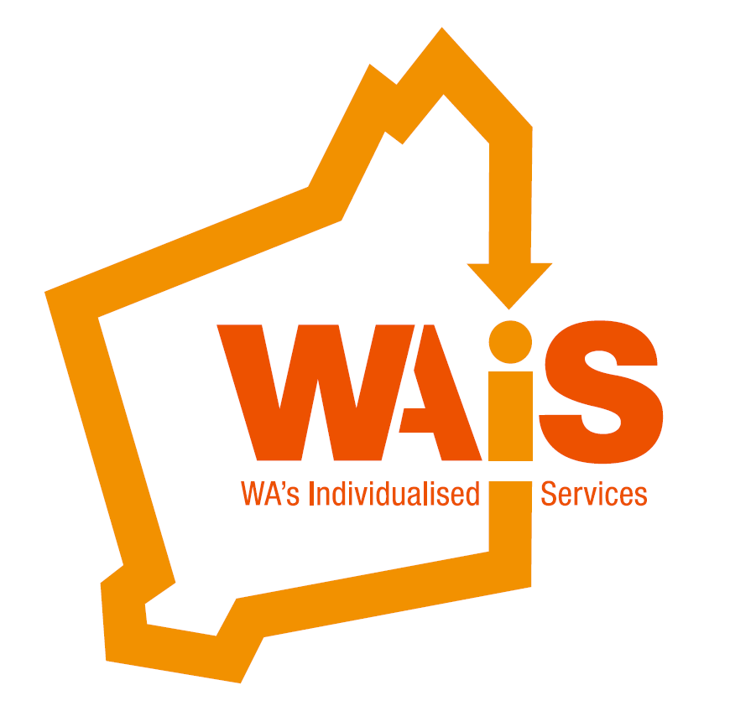
Membership Renewal

If you would like to continue your membership with WAiS, please pay the attached invoice and return this form to ensure your membership details are accurate for 2016-17. Thank you

Applicant name / Organisation
Address
Mailing Address (if applicable)
Phone |  |  | Fax
E-mail |  |  | Web

Individual* member Family member/ Carer* Organisation

Membership eligibility: * “Individual” means a person who has a disability, chronic illness or a mental illness, or a family member who is the carer of a person with a disability, chronic illness or a mental illness, or who is frail.
Contact Person:
Name
Position / Relationship to applicant
Phone |  | Email

Voting Representative: (for WAiS AGM). This person will be eligible to vote at the WAiS AGM.
Name
Position
Phone |  | Email

Additional people to be added to the WAiS mailing list:
Name | Email

If your annual income has changed please tick the appropriate box below and a new invoice will be emailed to your contact person.
Annual Funding Income | Annual Fee | Please tick
Up to $1,000,000 | $750
$1,000,000 to $5,000,000 | $1,500
More than $5,000,000 | $2,500
Unfunded / Associated Organisations | $375
Individual* | $100**  **A concession rate may be applied at the  discretion of WAiS CEO (if applicable).

