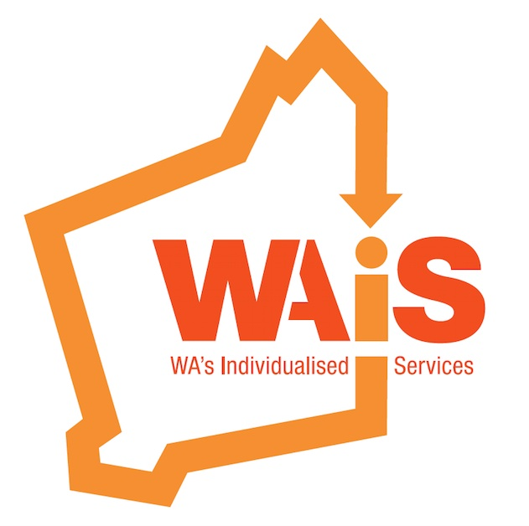

NDIS Bill and Rules Consultation 2021

Leanne Pearman Su-Hsien Lee
Co-CEO Co-CEO
l.pearman@waindividualisedservices.org.au s.lee@waindividualisedservices.org.au
0408 672 205 0499 747 404

Background: WA’s Individualised Services (WAiS)

Western Australia’s Individualised Services (WAiS) is a member-based community organisation working in partnership with people, families, service providers and government agencies to promote and advance individualised, self- directed supports and services for people living with disability, including psychosocial disability.

Since our inception in 2010, we have evolved to become thought leaders in this space, providing comprehensive, intentional support with integrity, passion and authenticity at our core. By leveraging our extensive local, state, and international network, we seek to lead, influence, innovate and inform to create meaningful and lasting change, supporting people to build capacity and live their lives on their own terms.

Unlike any other organisation, we partner and work with all sector stakeholders, as well as providing vital links, ensuring that disability services respond to the unique needs of people. We work to ensure that people can access and navigate the services and the sector to achieve their goals.

WAiS is the only organisation that has a specific focus and purview of supporting and developing the capacity of people, families, service providers, Local Co-ordinators and government, specifically in the area of individualised, self-directed supports and services.

WAiS membership has a focused group of people and their families and service providers who are committed to individualised supports, and people having choice and control in their life. The WAiS team also come from diverse backgrounds including people with disability, family members and people who have worked in the disability sector.

General Comments

Fundamental to the National Disability Insurance Scheme Act are the Objects of the Act. The very first object is to “give effect to Australia’s obligations under the Convention on the Rights of Persons with Disabilities”. In doing so, the Scheme is to “support the independence and social and economic participation of people with disability” and “enable people with disability to exercise choice and control in the pursuit of their goals and the planning and delivery of their supports”. To achieve all this requires then the establishment of the NDIS in Australia to “provide reasonable and necessary supports”.

The NDIS Act itself, has a strong foundation embedded with Human Rights, however, there are significant issues with how well the legislative framework is working with implementation.

National Disability Insurance Scheme Amendment (Participant Service Guarantee and Other Amendments) Bill 2021

Schedule 2, Section 45:

Amended Rule: National Disability Insurance Scheme (Plan Management) Rules 2013

Section 6 – Funding and provision of supports included in participant’s plan
The provisions in section 6 state that in circumstances where the NDIA has intervened in the market to support participants to access supports, or a participant’s choice and control in the delivery of their supports has been limited, it must be clearly identified in the participant’s plan.
Section 7 - Reasons for market intervention to be included
Section 7 provides that where the CEO does decide to specify a support in a
participant’s plan where market intervention is required in accordance with subsection
6(5), then the plan must include the reason for specifying those matters. This supports
the NDIA to deliver on the service standards aligned with transparency under the
Participant Service Guarantee.

Comments:
WAiS agree that the person with a disability needs to be an equal partner in the process, where market intervention is needed, and the reasons for the intervention to be clear, transparent and of benefit (not detriment) to the person.

Section 8 – Supports not to be provided by particular providers
Section 8 provides that the statement of participant supports included in a
participant’s plan may specify that a support must not be provided to the participant by a
particular person if the CEO is satisfied of one or more of a number of specified matters,
including whether:
- The provision of supports is not likely to substantially improve outcomes for the participant or benefit the participant in the long term
- The provision of the support is likely to adversely affect the participant’s inclusion in the community, or ability to exercise choice and control in relation to other supports in the plan.

Comments:
The power of the CEO to specify if a person can utilise a provider or not, is significant, and one that WAiS has concerns about. Whilst understanding the issue of conflict, specific vulnerability of some people and people accessing the right services for them, the CEO should not be able to ultimately veto a person’s choice of service provider.

Section 9 – Unreasonable risk—registered plan management provider, plan
nominee or child’s representative managing funding

Section 10 – Unreasonable risk—adult participant managing funding

Creating Your Plan

Using and Reviewing Plan

- LACs currently provide insufficient support to people who choose to self-manage. LACs in WA are seeking support from WAiS (as part of a WA State grant funded service) in this regard.
- People are concerned about losing funding if they don’t use it, especially if, for example, they are not able to use the funding because the service is not available or if they need help with implementation.
- People are concerned about transport funding. This includes insufficient funding and lack of flexibility of use. People may get funded supports to engage socially and economically but cannot physically get there due to transport barriers. This is particularly an issue in regional and remote areas. People are being told ‘you have used all your ‘kilometres’ this month so you can’t have transport support to go anywhere”. There is also an unclear age criterion so no consistency as to who gets it if the person is younger than 18 years old.
- In relation to the interim one month extension policy, there is lack of information in relation to what happens if someone has almost used up their annual budget.
- People do not understand their plans and LACs, when requested to, may read through it with someone, but this is not the same as explaining it. People don’t understand budget categories and what this means practically that they can spend the budget on.
- People experience difficulty navigating what supports and services are available and implementing them, without adequate support from experienced, and focussed LAC, SC or others.
- There is lack of clarity in relation to bank accounts and confusion as to whose name the account need to be in.
- There is lack of clarity around who is determined as family for the purposes of NDIA policy that family cannot be paid to provide services.
- People are concerned they will lose funding in areas where they need it, when they seek a review of a reviewable decision, as this triggers a review of their entire plan.
- Review of reviewable decision versus change of circumstances – there is a level of misunderstanding as to the difference. The timeframes for these impact on people when they have inadequate funding and may run out of funding before the review/appeal is completed.
- There is a lack of understanding as to whether a LAC can support someone to initiate a review or change of circumstances.

Recommendations:
- That people and families are provided adequate and easy to understand information to ensure they are fully informed and any fears allayed.
- That the NDIS developed a policy in relation to who and how someone is determined a “family member”.
- That plans are easy to understand.
- That people are adequately supported to implement their plans.
- That adequate information is provided in relation to reviewable decisions, reviews and appeals, and mechanisms for amending a plan, for example change of circumstances. This information should be both about what these are and what people can expect during each of these processes.
- That people should be able to have a plan that can start with the accepted funded supports, whilst they wait for a reviewable decision on the specific strategies/ decisions being challenged.
- That people should be able to use their WHOLE plan flexibly to meet their goals and outcomes, not just elements of Core Supports.
- That people can request a review of only a specific part of their plan.
- That the NDIA explicitly states its position in response to AAT decisions.

Appealing a Decision

- It would be of great assistance to people if it is made clear people can have an advocate and where they can go to for this advocacy. It is noted that there are notable advocacy waitlists, even for situations that have been deemed requiring urgent attention.
- The timeframe for appeals is too long.
- Anything that can be done to minimise the likelihood of reviews and appeals will minimise undue stress, anxiety and fear in relation to having to go through a review/appeal.

Recommendations:
- That people are pro-actively offered advocacy support when appealing and that this advocacy is available.
- That people are fully informed as to what to expect during an appeal process and that appeals are undertaken in as short a timeframe as feasibly possible.

Plan Amendments

- WAiS fully supports this option being made available.
- This needs to actually be a swift, easy option.
- Clarity is required, however, as to the distinction from change of circumstances, or review of reviewable decisions.
- This option needs to include people seeking a change of management option.
- Clarity is required as to at what point people can request this. WAiS assumes at any time during life of plan.
- Clarity is required as to whether this impacts on the timeframe of plans. WAiS assumes the plan duration remains the same and that this does not kick start a new plan period.

Recommendation:
- That a mechanism to enable swift minor plan amendments is offered to people.

