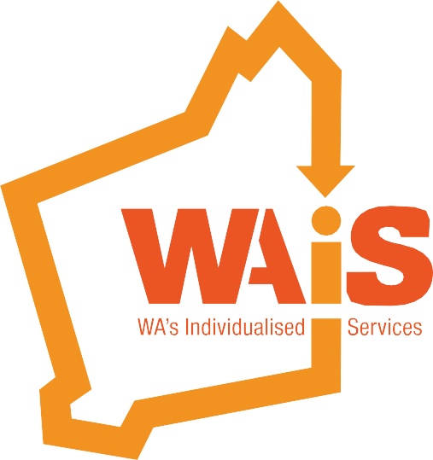

Planning for a good life
- It’s about ME!

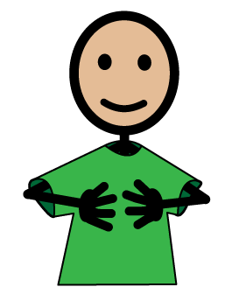
Name:
Date:
People involved/consulted in the planning:

Insert your picture here!

Insert your picture here!

Insert your picture here!

This resource was developed through a Western Australian grant funded by Department of Communities, Disability Services.

What is my story?

Things I want to change?
What works for me?

What do I like?

Likes

What do I dislike?

Dislikes

What are the things I love, or am passionate about?
What do other people love or admire about me?

What is important TO me?

(What I need to be safe, well & healthy?)
What is important FOR me?

(What makes me happy and content)

Great things about Me
Gifts of the head

Knowledge, questions, experience, information I can contribute; figuring people out, organising and classifying things, travel routes, sports, news, fan information, gossip, local history, ability to spot a bargain, ability to debate, sales ability, creative thinking, math, solving puzzles, interests in politics, desire to think about big questions etc.
Gifts of the body

Abilities, skills that I can contribute; recognising people, remembering names, dancing, fixing things, singing, typing, drawing, arranging things, using a computer, decorating, acting, composing, figuring things out, sewing, working hard using physical strength, ability to sign, speak or understand another language etc.

Gifts of the heart

Interests, enthusiasms, personal passions and the rewards
I bring to others; welcoming people, patience, courage, sensitivity to others, high energy, desire for order, ability to listen, passion for justice, love of nature, ability to draw others out, spiritual gifts, etc..

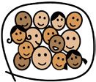
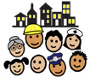
What support do I need to maintain and develop relationships?

Community
Friends
Paid
Family
Who is important to me? (insert names and photos (where possible)

My Relationships
My Community

What community facilities would I like to access in the future?

(Dr, Physio, Speech, OT, Church, Gym, School, Tafe, Uni, Sporting groups etc.)
What community facilities or services do I use?

(someone with me, transport, accessibility, etc.)
What support do I need to access community places?

My Sport, Recreation & Leisure
(someone with me, transport, accessibility, etc.

(Physio, OT, Church, Gym, School, Tafe, Uni, Sporting groups etc.)
What support do I need to access my sport, recreation and leisure?

What sport, recreation and leisure facilities would I like to access in the future?
What sport, recreation and leisure facilities would I like to access in the future?

What sport, recreation and leisure facilities or services do I use?

My Work

What am I doing now for work?

What do I like about it?

What would I like to change?

What would I like to try in the future?

My Life Long Learning

What support do I need to access it?

What courses or learning would I like to do into the future?

What courses am I doing/ have done?

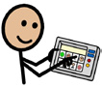

Communication

Happy
Sad
Angry
Frustrated
How do I let you know that I am feeling:

(Using words, symbols, pictures, photos, gestures/pointing, signing, objects, technology, charts, visual schedules etc.)
What are the ways I communicate?

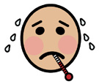
Sick

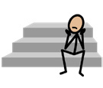
Safe
Unsafe
Lonely
Bored
Scared
Anxious
Sore
How do I let you know that I am feeling:

Help, Something, Affection, Some attention, Time alone, Time together, To do something/something else, To see someone, To go somewhere, To come home.
I am saying or meaning yes or no, Something is right/wrong, My likes/dislikes, Who I like/dislike spending time with, When something is working or not working for me.
What support do I need to communicate and/or help to communitcate with me?

How do I let you know?

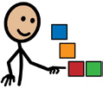

My Choice and Control
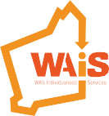
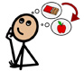
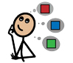
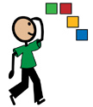
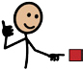
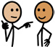
This project is an NDIS Information, Linkages and Capacity Building (ILC) initiative.
For more ILC events and resources please visit www.waindividualisedservices.org.au
http://www.disability.wa.gov.au/wa-ndis/wa-ndis/information-linkages-and-capacity-building/resources/
Experience to explore
The right
assistance for me
Explore all
options
Understand me
and my preferences
Are the right
people involved?
It’s up to me
One decision
at a time
I can change
my mind
Assume I can
SUPPORTED DECISION MAKING PRINCIPLES
Each person must know and understand their human rights in order to be able to claim them, defend them, and hold themselves, other people, their governments, and societies accountable for the actions that affect them. Human rights are common to all people.

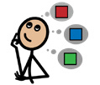

Decision Making

Decisions I make myself

Decisions I am supported to make

Decisions made by others
(Eg. To be kept safe from abuse and neglect, to express my views, to be autonomous, to vote, to access education, employment, buildings etc.)
What support do I or my supporters need to help me exercise my rights or make decisions?

Decision Making
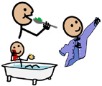

My Daily Life

Community
Home
Personal Care
(E.g. personal care, personal hygiene, domestic tasks, community skills, money handling, administering medication, hanging out washing, ironing, ooking, cleaning, shopping, telephone skills, transport skills, safety skills, money handling, budgeting, use of banking facilities, etc.)
What support and/or assistance do I need with personal tasks of daily life?

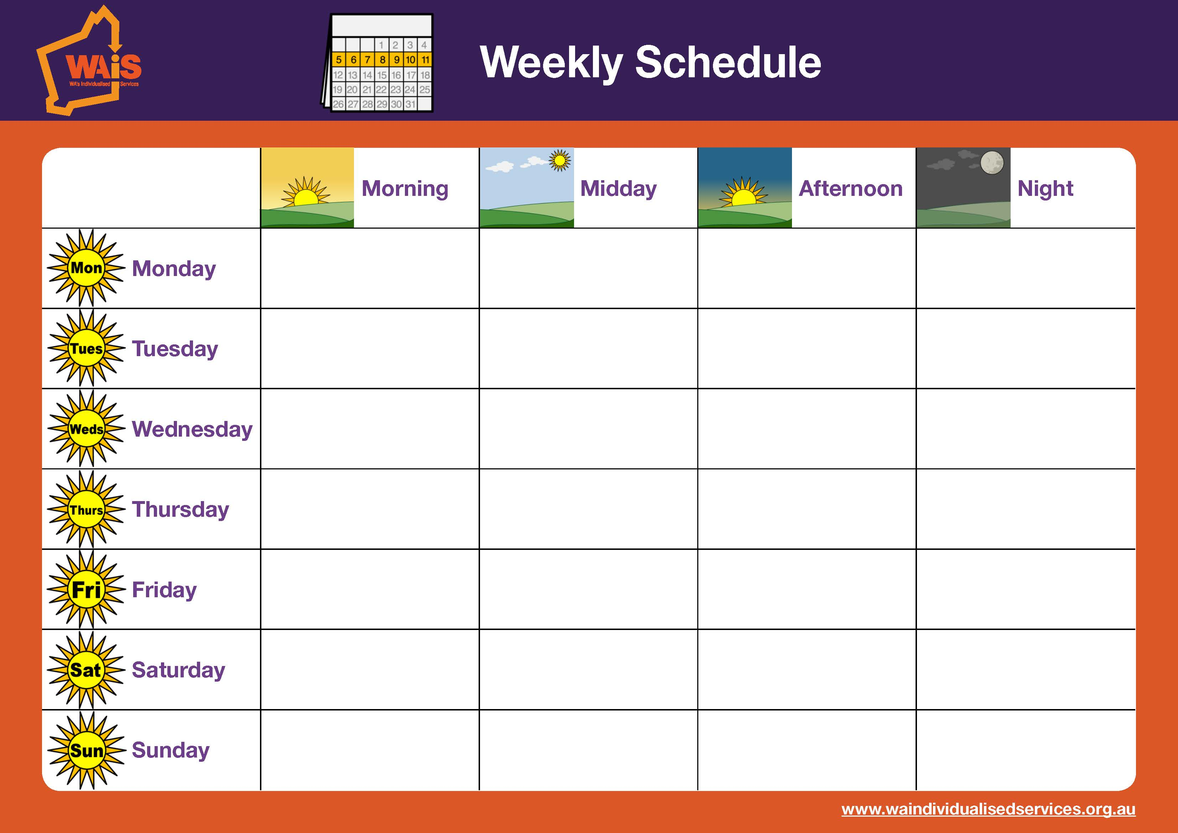

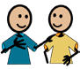
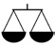
My Legal/ Justice Support

What support do I need?

Are there any legal or justice issues?

(someone with me, transport, accessibility, etc)

(i.e. Medical, Physical, Emotional, Dietary, Podiatry, Audiology, Vision)
Medication I am on

What support do I need?

What is my health like now?

My Health & Wellbeing
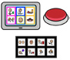
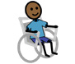

(Technology, equipment and/or adaptive equipment e.g. ramp, wide doorways, hoist, electric door, grab rails, modified taps etc.)
Who services my equipment?

Is there any equipment that I would like into the future?

What equipment do I currently use?

My Equipment
Do I have any accessibility needs?

My Therapy

(Occupational Therapist, Speech Therapist, Physiotherapist etc.)
Is there any therapy I might need into the future?

Who do I see and how often?

My Vulnerabilities

What vulnerabilities need to be explored?
Using the framework below from Model of Citizenhood Support 2nd Edition 2013 (Robbi Williams) is helpful when thinking about vulnerabilities and safeguards to invest in.
Understanding Capital
Identifying the gaps
Measuring the risk given the gaps - high/low
Focused investment to build capacity
Reduce risk and increase capacity and outcomes

Empowering Safeguarding

Model of Citizenhood Support talks about ‘Four Capitals’
The Four Capitals are different but interrelated types of assets we can call upon.
In considering the circumstances of people living with increased vulnerability, the Model of Citizenhood Support finds how the person might best be assisted to move into a life of active Citizenhood if there is an active focus on each of the Four Capitals to the degree that’s right for the person’s situation.
There are useful anchor points including:
- The assumption of potential, where the goal of Citizenhood is available to all people regardless of the precise form that it takes; despite personal circumstances each person has characteristics that are assets to the person and to the wider community
- The assumption of Personhood, where the person is front and centre to any decisions that affect them
- The assumption of risk, because it exists in all aspects of life, and the corresponding attention to safeguards, because their presence can help navigate risk and advance and uphold the person’s place in community life.

Model of Citizenhood Support
Social Capital
Knowledge
Capital
Material Capital
Personal Capital
Life Chances

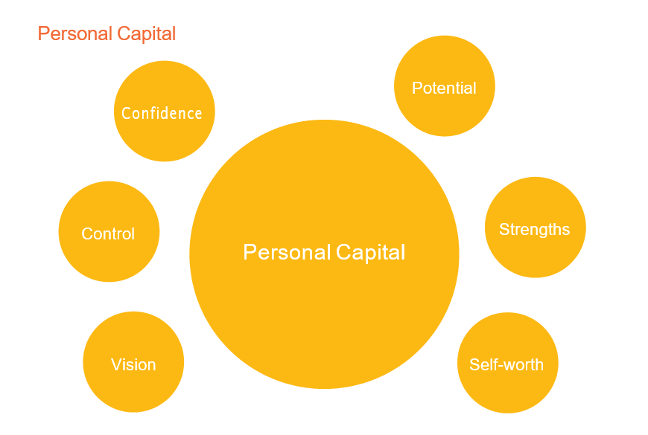
For a person to advance their chances of living a good life it is important for them to have a sense of who they are, their worth, and the vision or dream they are moving towards.
Building Personal Capital is about building belief in ourselves – our potential, strengths, dream of what might be possible in our lives, personal agency (the decisions and actions we take) and self-worth.
- Understanding the Person’s Story – The art of listening
- Understanding the Effect of Services – The art of reflecting
- Responding to Personal Service Trauma – The art of healing
- Assisting a Person to Imagine What Might be Possible and Take Steps Towards It – The art of planning
- Building a Life – The art of authoring
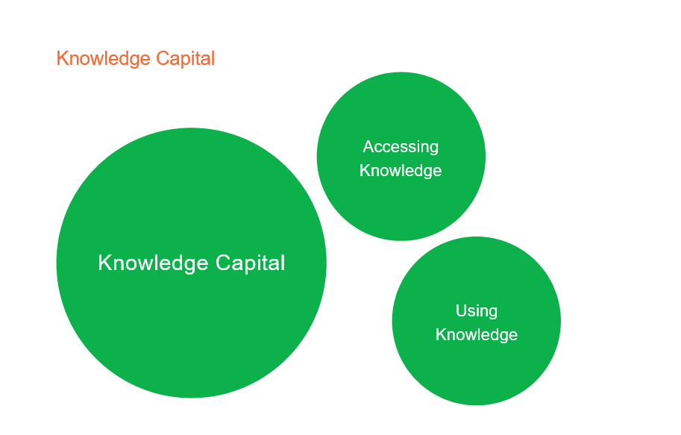
Knowledge Capital refers to two main considerations: first, how a person might make the best use of the knowledge, skill and information pathways they already have, and second, how a person might access more.
Building Knowledge Capital is about building our capacity to access, understand and apply information
- Upholding and Advancing Knowledge Capital
- Issues of Access
- Issues of Filters

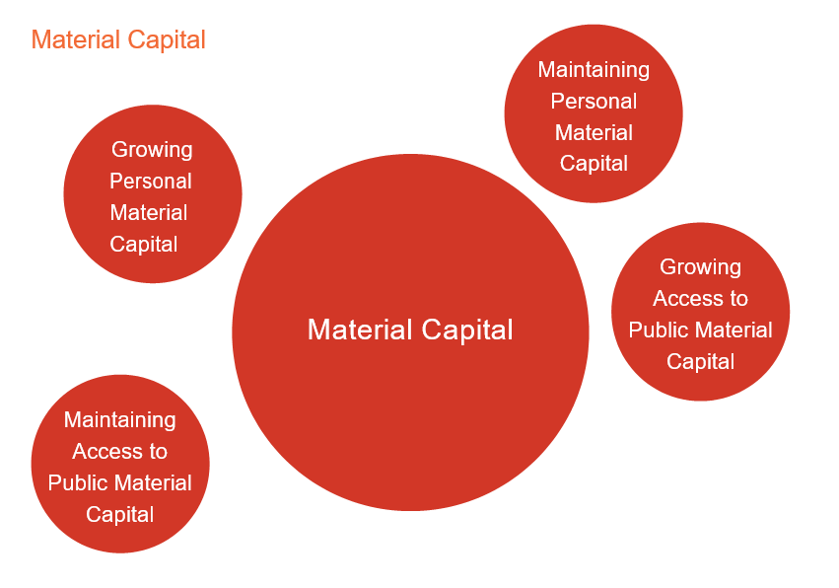
Personal Material Capital refers to tangible assets owned or controlled by the person themselves. Such assets might include money, for example income or savings, and property, for example housing, vehicles, and various personal effects including durables like furniture and consumables like groceries.

Building Material Capital is about growing the range of personal material resources under the ownership or control of the person and building the person’s use of typical public material resources.
- Upholding Personal Material Capital – Respect and Care
- Upholding Access to Public Material Capital – Avoiding the Creation of “Special”
- Advancing Personal Material Capital – Finding Meaningful Paid Work
- Advancing Personal Material Capital – Creating Personalised Budgets
- Advancing Public Material Capital – Features of Access in Community Life

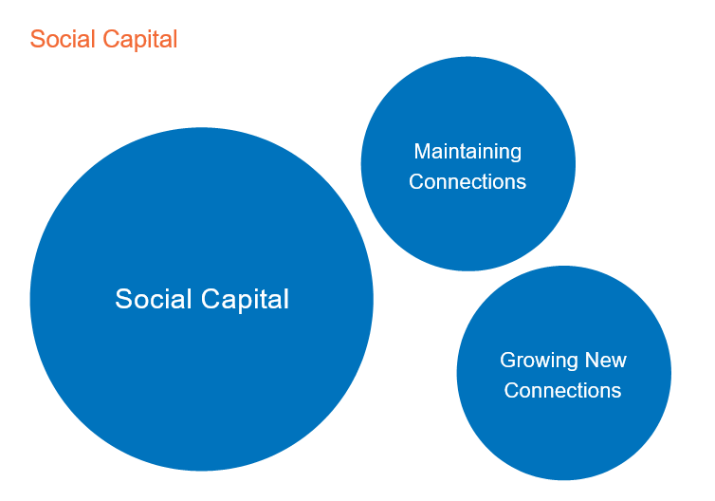
There are two main aspects of Social Capital; these are Connection and Fellowship.

Connection refers to the extent to which we have contact with other people.
Fellowship refers to connections that have moved beyond their initial functional or situational nature to become a relationship where there is deeper mutual regard, the development of trust, and the establishment of a bond.

Building Social Capital is about growing the number and range of active social connections in a person’s life, so that the person’s daily routines are rich with opportunities to connect with people, and rich with the possibility that those connections will give rise to additional new connections and deepen into Fellowship.
- Upholding Social Capital – The art of the Executive Assistant
- Advancing Social Capital – The art of introductions
- Advancing Social Capital – The art of building a welcoming, integrated community life

Level of Capital | Level of Persona Capital | Level of Knowledge Capital | Level of Social Capital | Level of Material Capital | Risk
Significant Capital | Ability to self- advocate, strong identity, ability to make decisions, confident  in self-determination, autonomous physical capacity. | Have recognised qualifications, skills and expertise. The capacity to access knowledge and information and to act on this knowledge. | Lots of people connected to the person inc family, friends, strong community presence and participation. | I am financially secure, with sufficient resources to meet my  needs. I have a job and security of tenure.
Reasonable Capital | Can make significant decisions known, limited understanding of their identity, resonable sense of confidence, reasonable control over physical autonomy. | Have knowledge and expertise that enables the person’s lifestyle. Limited access to info and can act of this info. | Family, friends, some community presence. | I have sufficient funds to meet my needs and lifestyle, with security of tenure. | Low
 |  |  |  |  | Risk
Fair Capital | Require support with decision making, limited self advocacy, limited understanding of own determination/ direction inc wishes and needs. | Require support to acknowledge / promote skills and contributions. Require support to access info. | One or two family, paid support team, no  community connections. | I have limited funds and mostly manage to meet my needs and lifestyle, with limited security of tenure.
Low Capital | Little personal capacity in making major decisions, limited communication, limited autonym over physical space and limited ability to create direction. | Limited education, lack of access to info and knowledge. Limited and disconnect to cultural knowledge and communities. | No unpaid people in life, limited paid people. | Reliant on income support, no employment, no inheritance, no secure housing, debt, living in a community with limited resources.
High Risk

My Risk and Vulnerability
Across all areas there is some level of risk for all citizens; however, measures enable us to consider given the persons capital, whether the risk low or high. Therefore, we can add alongside the measure of capital an easy to use measure of risk;
- the more capital a person has, the lower the risk
- the less capital a person has, the higher the risk

What are my specific areas of vulnerability and where am I at risk?

This process is generally the safeguarding of the individual needs of the person and the people involved. It considers the vulnerable areas across ALL areas of the person’s / people life (all areas in this document) and is intended to identify actions that need to be implemented.

What safeguards do I need?

My Additional Vulnerabilities Information

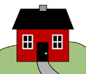

My Home Now
(Describe how I live – with whom, where, how, with what support)
My home now

My Home in the
Future
(Describe how I live – with whom, where, how, with what support)
My home in the future

(Where do I want to live, who do I want to live with, what do I want to be doing, with whom etc.)
How do I want to live my life? (My Vision)

Goals

(Think about the action, by when and by whom)
Actions

My Photos

My Photos

My Photos

Notes

Notes

